Fauna Bone

AN 3571 Archaeological Methods & Theory

Professor [Suzanne Spencer-Wood](mailto:spencerw@oakland.edu)

Marcus Dennehy

| Number | Animal | Bone | Wild/Domestic | Condition |
| --- | --- | --- | --- | --- |
| 1 | Chicken/Gallus Gallus | Pelvis | Domestic | Chewed |
| 2 | Chicken/Gallus Gallus | Femur | Domestic | Whole |
| 3 | Chicken/Gallus Gallus | Ischium | Domestic | Whole |
| 4 | Chicken/Gallus Gallus | Clavicle | Domestic | Whole |
| 5 | Pig/Sus scrofa | Rib | Domestic | Whole/Damaged |
| 6 | Chicken/Gallus Gallus | Femur | Domestic | Whole |
| 7 | Chicken/Gallus Gallus | Femur | Domestic | Whole |
| 8 | Chicken/Gallus Gallus | Humerus | Domestic | `Whole |
| 9 | Chicken/Gallus Gallus | Tibia | Domestic | Whole |
| 10 | Wild Turkey/Meleagris Gallopavo | Cervical vertebrae | Wild | Whole |
| 11 | Chicken/Gallus Gallus | Thoracic vertebrae | Domestic | Whole |
| 12 | Chicken/Gallus Gallus | Cervical atlas vertebra | Domestic | Whole |
| 13 | Chicken/Gallus Gallus | Cervical vertebrae | Domestic | Whole |
| 14 | Chicken/Gallus Gallus | Lumbar vertebrae | Domestic | Whole |
| 15 | Chicken/Gallus Gallus | Radius | Domestic | Whole |
| 16 | Chicken/Gallus Gallus | Clavicle | Domestic | Whole |
| 17 | Chicken/Gallus Gallus | Ulna | Domestic | Whole |
| 18 | Chicken/Gallus Gallus | Rib | Domestic | Whole |
| 19 | Chicken/Gallus Gallus | Ischium | Domestic | Whole |
| 20 | Chicken/Gallus Gallus | Fibula | Domestic | Whole |
| 21 | Chicken/Gallus Gallus | Scapula | Domestic | Whole |
| 22 | Chicken/Gallus Gallus | Patella | Domestic | Whole |
| 23 | Pig/Sus Scrofa | Rib | Domestic | Fragment |
| 24 | Chicken/Gallus Gallus | Ischium | Domestic | Whole |
| 25 | Chicken/Gallus Gallus | Humerus | Domestic | Whole |
| 26 | Chicken/Gallus Gallus | Humerus | Domestic | Chewed |
| 27 | Pig/Sus Scrofa | Tibia | Domestic | Cut |
| 28 | Pig/Sus scrofa | Femur | Domestic | Cut |
| 29 | Ovis aries/Sheep | Femur | Domestic | Cut |
| 30 | Cow/Bos taurus | Lumbar vertebrae | Domestic | Whole |
| 31 | Deer/Odocoileus verginiaunus | Thoracic vertebrae | Wild | Whole |
| 32 | Deer/Odocoileus virginianus | Femur | Wild | Cut |
| 33 | Deer/Odocoileus virginianus | Rib | Wild | Whole |
| 34 | Deer/Odocoileus virginianus | Rib | Wild | Chewed |
| 35 | Deer/Odocoileus virginianus | Antler | Wild | Cut |
|  |  |  |  |  |

C. 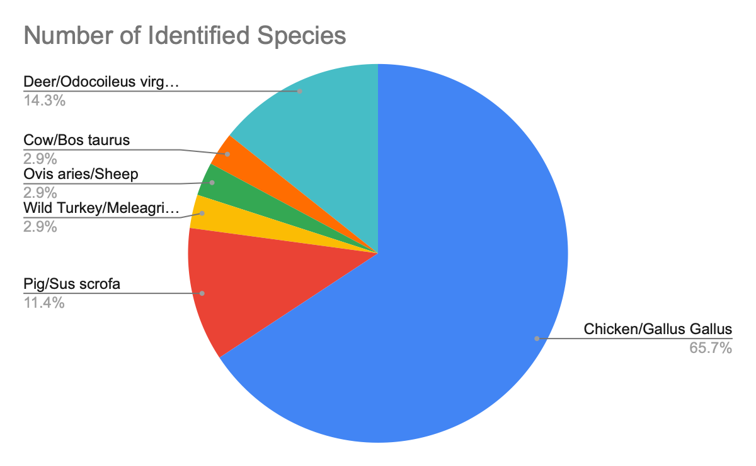

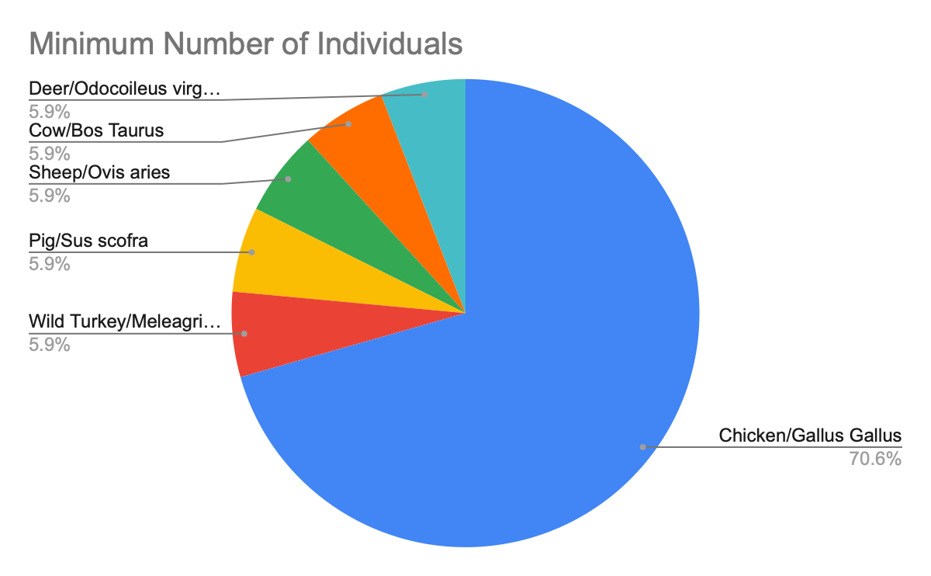

D.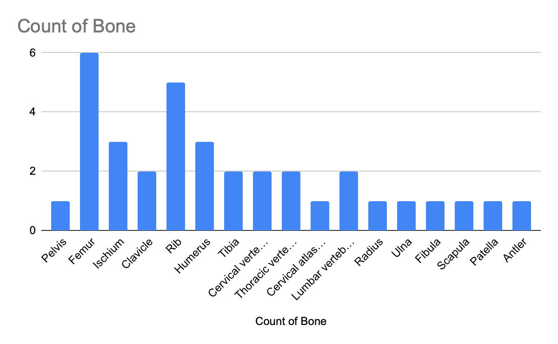

E. 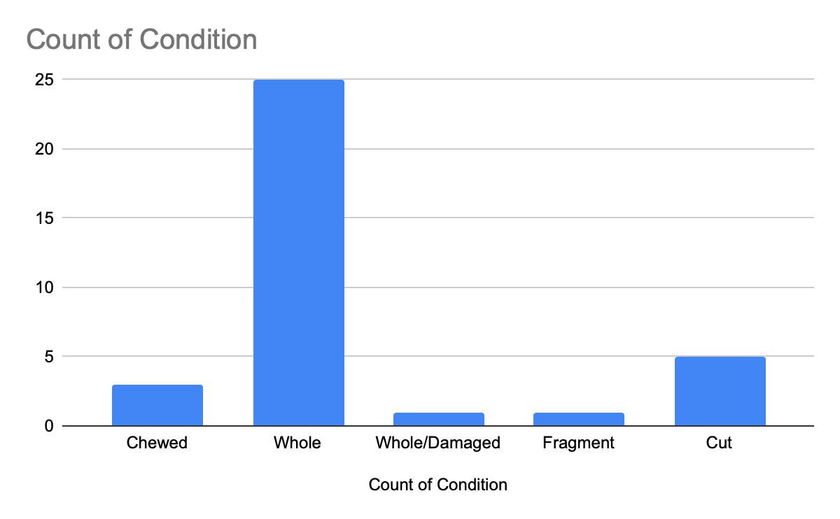

F. 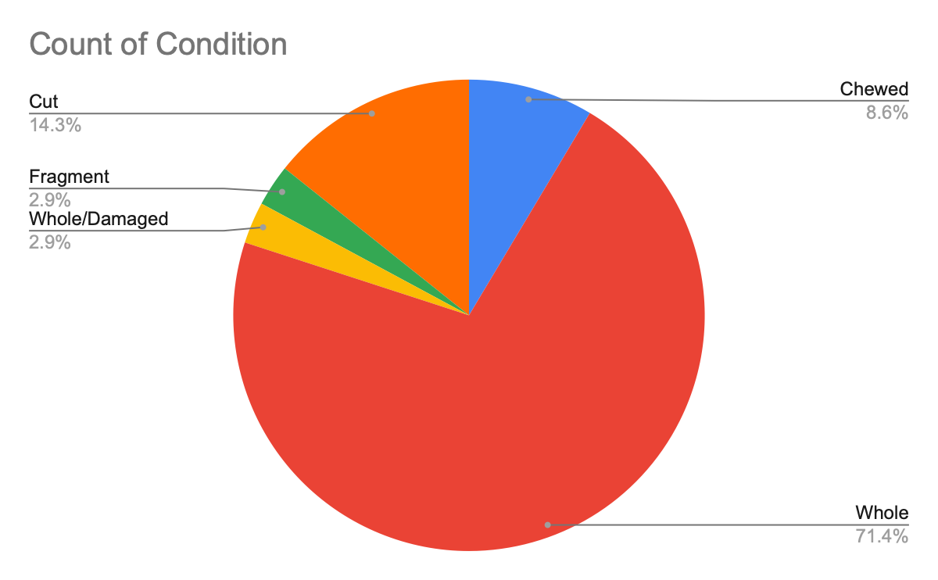

G.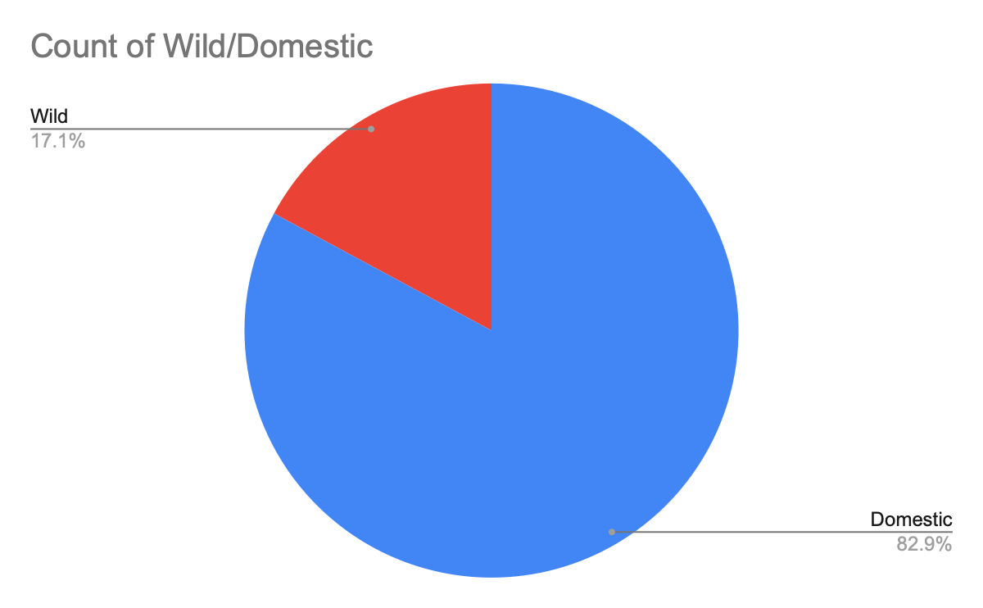

1. The NISP shows the number of specimens found from bones that have been identified with that species. NISP shows more of the types of food that was eaten, which was definitely chicken in this study. The MNI is the minimum number of individuals that were identified from a species. This shows the possible amount of animals killed, as individual and unique bones show the exact individual specimen.
2. The chickens were most likely domesticated, as well as the pigs, cows and sheep. However, wild turkeys were identified, with a collection of Deer bones. These tell me that the location must have been on a farm, near the edge of the woods. 82.9 percent of the bones found are considered domesticated while only a small percentage, 17.1 percent, were identified as wild. Most likely that this was a chicken farm with a couple of other pasteurized animals like pigs, sheep and cow.
3. Chicken season is especially important in the summer, the other domesticated cattle seemed to be slaughtered when they were very young. The deer may have been hunted in february, as the antler identified shed its antlers to full maturity. However, the turkey remains unknown, whether or not it was hunted down in the forest like the deer remains to be seen.
4. The conditions of the bones are varying. Although most of these bones are left whole, about 71.4 percent, the rest have been altered by humans or other animals. Unfortunately, there seemed to be no prehistoric bone tools that were shaped into hunting or fishing instruments. A lot of the cattle however, about 14.3 percent of their bones were sawn. This can be seen in number 29, where a sheep femur was sawn. This can be up close with kerf marks being identified on both sides. A lot of these cattle femurs have sawn bones. This is most likely a european American site due to all the kerf-marks of the saw identified on the bones.
5. Chicken were the most important food animal out of all the identified species. However, their diet also consists of pigs, cows and sheep. Wilder animals like turkey and venison were also on the menu. One non-food bone was found, that being a mature antler of a deer.
6. From the evidence collected at the site. We can say that this was a wealthy family at the end of the 1800s. Chicken became a higher status meat at the time, increasing its price to that of lamb, steak or venison. Hunted animals would need ammunition and a gun in order to fell a beast such as a deer or a turkey. Hunting these animals would require the cost for all these things, this including time to hunt them in the first place. The cut pieces of leg bone suggest that most of the pasteurized animals were cut to produce loin, ribs and steaks. This shows that not only chickens were being bred here, but cattle that would later be sold as cut foreshanks.
7. Firstly, small sample size reduces the effectiveness of the study, as it doesn’t show all of the other bones that were left out. This could leave some crucial information on what other bones were found. The advantages of the small sample size allows us to quickly get a perspective on the inhabitants and the style of living.